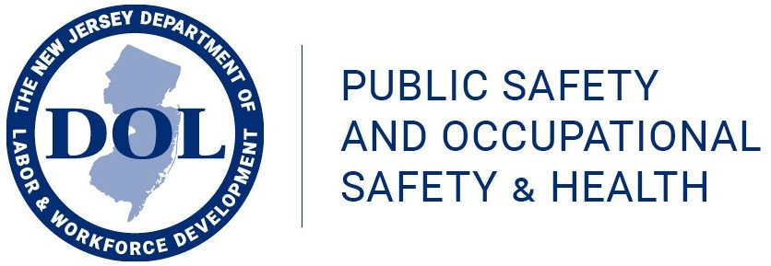
The Occupational Safety and Health On-Site Consultation program provides free On-Site Safety and Health Consultation and Training services to private sector employers. Trained staff identify safety and health violations of the OSHA Standards and work with employers to improve their internal occupational safety and health management systems. Through this program, employers can find out about potential hazards at their worksites, improve their occupational safety and health management systems, arrange safety and health training, and even qualify for a safety recognition award.
Knowledge of your workplace hazards and ways to eliminate them can only improve your own operations -- and the management of your firm. You will get professional advice and assistance on the correction of workplace hazards and benefits from on-site training and assistance provided by the consultant to you and your employees. The consultant can help you establish or strengthen an employee safety and health program, making safety and health activities routine considerations rather than crisis-oriented responses.
The Occupational Safety Training Program provides occupational safety training for private sector employers and employees. The training is delivered by experienced consultants who will customize courses for employers when needed. The safety training programs were, in most cases, developed using the requirements of the appropriate OSHA standards and are intended to teach both employees and employers how to maintain a work environment that is free of recognized safety and health hazards. The safety training staff receive training through an OSHA Training Institute Education Center to keep abreast of changes in OSHA Standards.
All training is provided at no cost to the employer and is provided at the employer's facility. This no-cost training is available to Workforce Development Partnership Program grantees and other organizations who are conducting vocational or occupational training.
Employers can learn more about available services, and request these services, by contacting Elayne McMullen at (609) 633-2587 or by e-mail to elayne.mcmullen@dol.nj.gov.

